PROJECT DESIGN PHASE
SOLUTION ARCHITECTURE
Date | 21 October 2026
Team ID | Individual Project
Project Name | Online Complaint Registration
Maximum Marks | 4 Marks

Solution Architecture
Solution architecture describes how the application’s user interface, backend services, database, and security controls work together. For this project, a layered MERN architecture separates presentation, application logic, and persistent data. It supports three roles—ordinary user, agent, and administrator—while applying backend authorization to protected actions.

Architecture Diagram
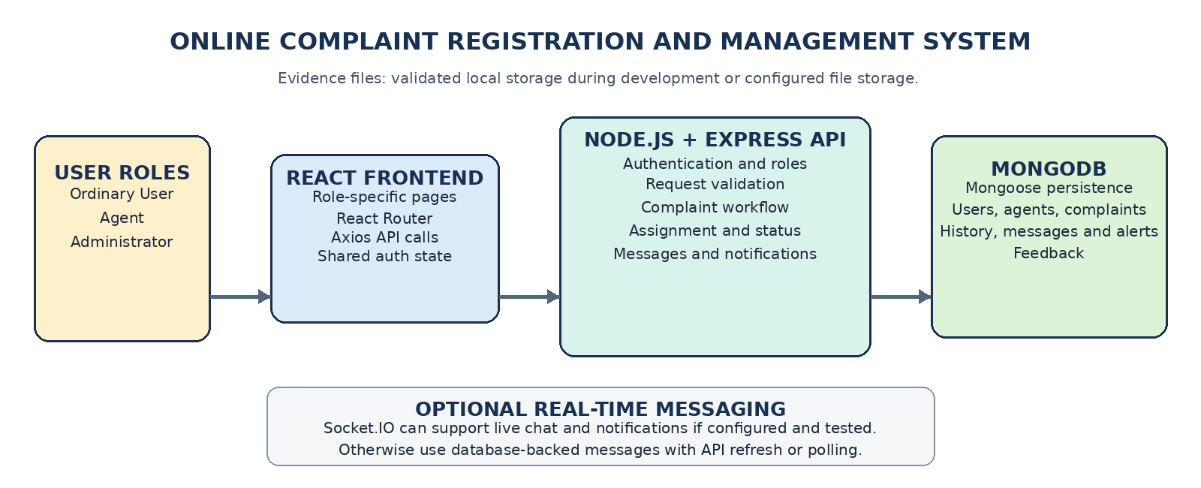
Figure 1. Proposed high-level architecture and primary data flow for the Online Complaint Registration and Management System.

1. Architecture Objectives
- Provide one web portal with role-specific screens for users, agents, and administrators.
- Keep application rules and access control in the Express backend rather than relying on frontend visibility alone.
- Store users, complaints, assignments, complaint history, messages, notifications, and feedback in MongoDB.
- Keep the code modular so authentication, complaint workflows, messaging, and administration can be tested and maintained separately.

2. Main Architecture Components
Component | Technology / Mechanism | Responsibility
Presentation Layer | React.js, React Router, Bootstrap or Material UI | Displays the public landing page and role-based dashboards, forms, complaint details, history, messages, notifications, and feedback interfaces.
API Communication | Axios client and REST endpoints | Sends requests to the backend, attaches the chosen authentication credentials, and presents loading, success, and error states.
Application Layer | Node.js and Express.js | Implements authentication, request validation, complaint registration, assignment, status transitions, message handling, feedback, notifications, and administrative functions.
Security Layer | JWT-based authentication, bcryptjs, authorization middleware, Helmet, CORS, rate limiting | Verifies identity and role, hashes passwords, validates access to each resource, and applies web security configuration. Secrets are kept in environment variables.
Data Layer | MongoDB and Mongoose | Persists users, complaints, complaint history, messages, notifications, and feedback; validates document shapes and provides indexes for commonly queried fields.
Communication Layer | Database-backed messages and in-app notifications; Socket.IO if configured | Allows authorized users and assigned agents to communicate about a complaint. Real-time delivery depends on Socket.IO being integrated and tested.
Evidence Storage | Validated local storage during development or configured file storage | Stores complaint attachment files or references with file type and size validation. A cloud provider is not assumed to be configured.

3. Primary Request and Data Flow
- Authentication: A user submits registration or login details through React. Express validates the request, uses a hashed password for credential verification, and returns the configured authentication response.
- Complaint submission: The authenticated user submits complaint details. The backend validates the request, creates the complaint in MongoDB, generates a reference number, and records the initial history entry.
- Assignment: An authorized administrator selects an eligible agent. The backend verifies the action, saves the assignment, records it in complaint history, and creates relevant notifications.
- Progress and resolution: The assigned agent views permitted complaint details and submits a valid status update or note. The backend checks assignment and workflow rules, updates the record, and records who performed the action.
- Communication and feedback: Authorized participants exchange complaint-related messages. After a complaint is resolved, the user may submit feedback if permitted. Related records are stored in MongoDB.

4. Data Collections and Relationships
Collection | Key data and relationships
Users | Contains name, email, password hash, role, account status, and timestamps. Roles are USER, AGENT, and ADMIN.
Complaints | Belongs to a user and may reference an assigned agent. Stores reference number, title, description, category, priority, current status, attachment references, and timestamps.
Complaint History | References a complaint and records status/assignment changes, actor, optional note, and timestamp.
Messages | References a complaint and sender; access is restricted to permitted participants and authorized administrators.
Notifications | References the recipient and optionally the associated complaint; stores message, type, read status, and timestamp.
Feedback | References the resolved complaint and submitting user; stores rating, comment, and timestamp.

5. Security and Design Considerations
- Hash passwords; never store or return plaintext passwords.
- Protect all private APIs with authentication, role checks, and resource-ownership or assignment checks.
- Validate all inputs on the server and enforce allowed complaint status transitions.
- Keep connection strings, JWT secrets, and optional email credentials in environment variables and out of source control.
- Restrict uploaded file types and sizes, generate safe filenames, and prevent unauthorized attachment access.
- Use consistent error responses without exposing credentials, stack traces, or database internals.

6. Deployment and Scope Notes
During development, the React client and Express server may run as separate local processes. MongoDB may be local or hosted through a configured MongoDB Atlas connection. The exact ports, environment variables, file-storage provider, and real-time messaging mechanism must match the implemented project configuration. Optional services must not be described as operational until configured and tested.

Conclusion
The proposed architecture separates the React interface, Express application services, security middleware, and MongoDB persistence. This design supports complaint registration, assignment, tracking, agent communication, notifications, administration, and feedback while keeping authorization and data validation in the backend.

